PIT X B PG 2 (41358)

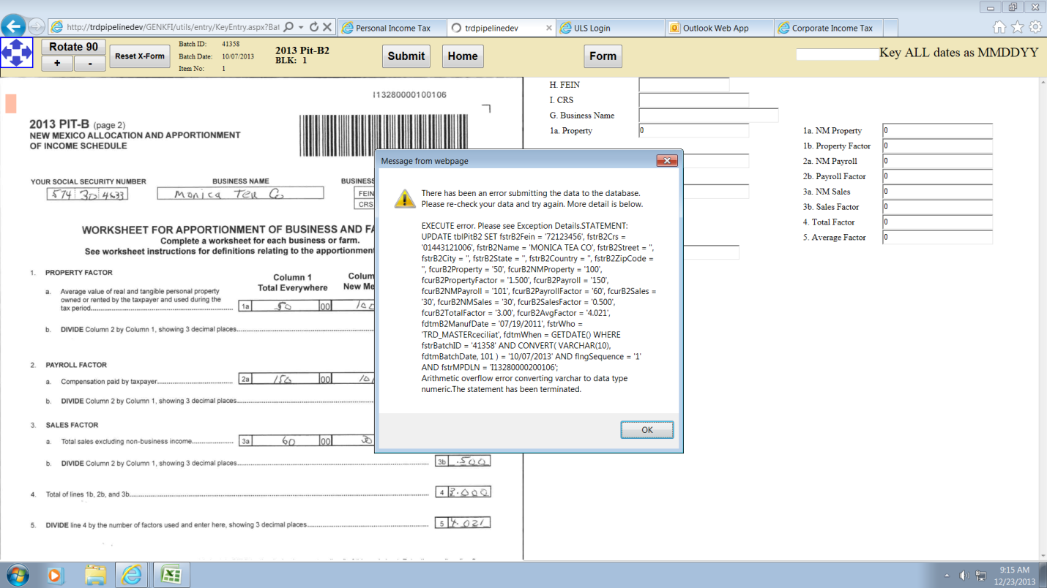

Error occurred when the G, election date was keyed. I took off the CRS number and it allowed me to proceed to the CR schedule.

PIT X PG 3

“Amended Column”

|  |  |
| --- | --- |
| 9. Federal Adjusted Gross |  |
| 10. Tax Deduct Claimed |  |
| 11. Addition PIT-ADJ |  |
| 12. Fed Std-Itemized Ded. |  |
| 12a. Itemized? |  |
| 13. Fed Exemption Amt |  |
| 14. NM Low Income |  |
| 15. Total Ded. Exempt |  |
| 16. Medical Care Exp |  |
| 16a. Unreimbursed Med |  |
| 17. NM Taxable Income |  |
| 18a. R=Rate Table, B=PIT-B |  |
| 18. Tax Amount |  |
| 19. Add Lump Sum |  |
| 20. Another State Tax |  |
| 21. Non-Refundable Cred |  |
| 22. Net NM Income Tax |  |

During training most employees don’t know which column to key. This would be for their benefit.

SCORP PG 1 (521)

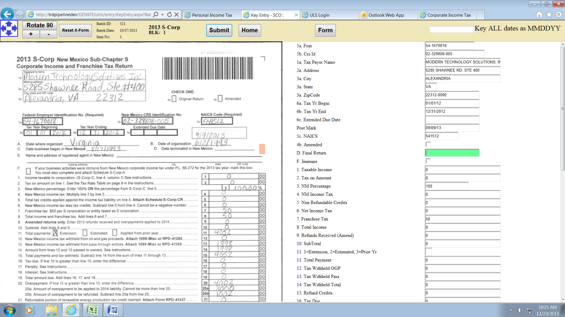

The “Original (4a)” and the “Amended (4b)” are automatically entered on paper version when assigning the batch to an employee therefore there is no need to mark this on the current application. As for this version I am not sure how this will play out in the batching process and how it will affect data entry. I am assuming it will be a “key what you see” situation. Amended returns are supposed to be batched separately however if this function is to be keyed I am unsure how to proceed. Normally in this case of an Amended return in an Original batch the entire batch is sent back to the processing department to get reimaged. In this current version there is no way to reject or resend the batch to the processing department. This will need to be for Phyllis Martinez to determine. This should be the same for CIT and PTE.

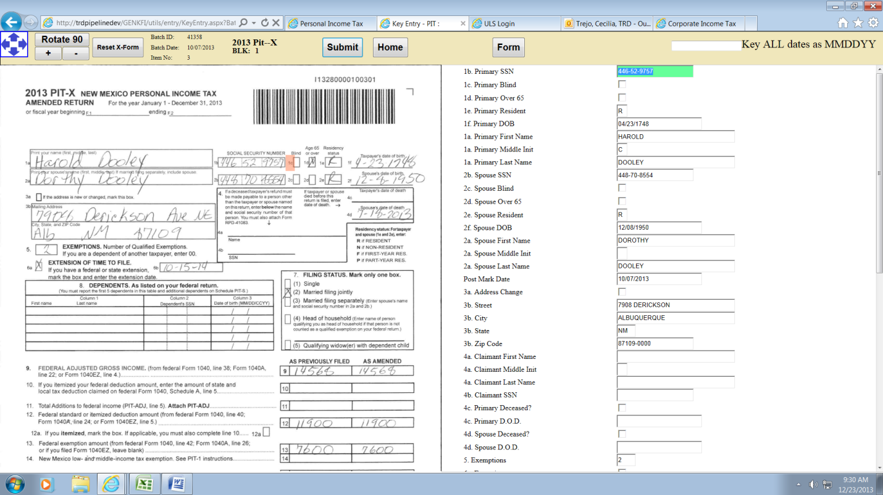

TYPED “09/23/1748” (KEY AS WE SEE IT) and the error below occurred

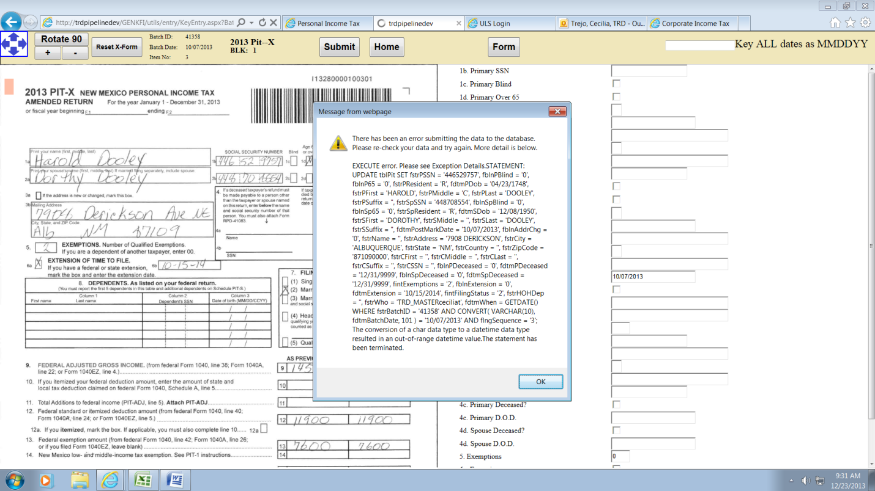

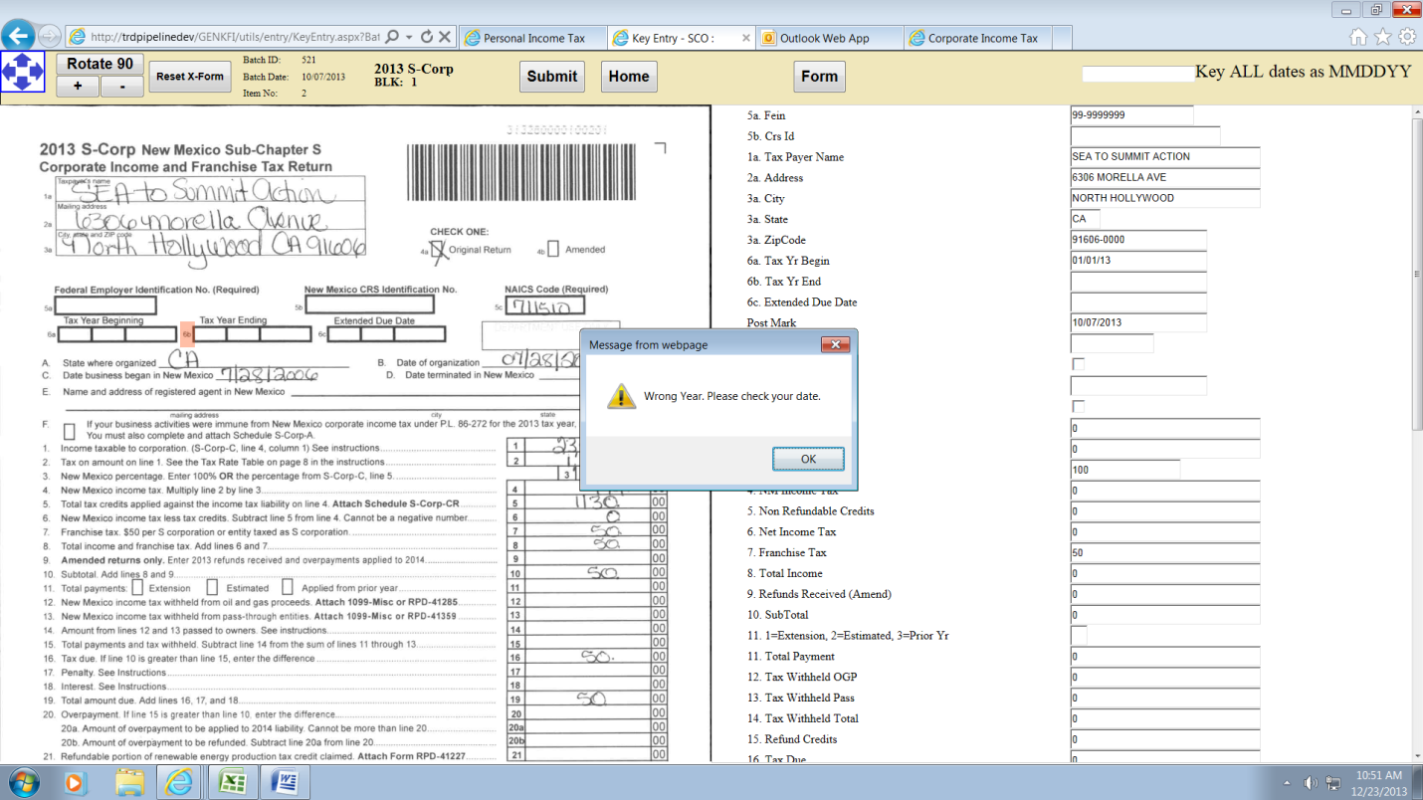

Keyed a two digit year and this error occurred. This happened with PTE and CIT as well.